Colour code and design theme
Letter -Gold & white

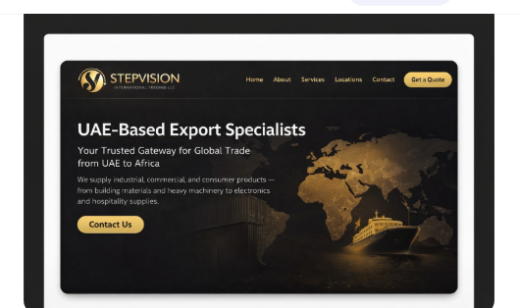

- This is the current one, instead of this content ,use the content of the first version.

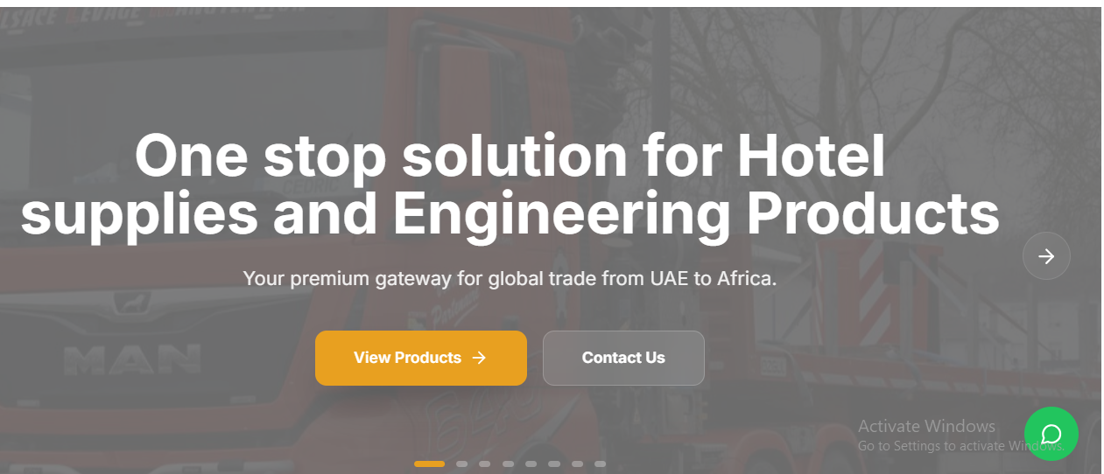

CHANGE AS BELOW

Use the same content as below ( back ground image supposed to be with map and vessel (refer the sample image/design). Change required in the content is “remove across 8 major categories” . adjust the size with image
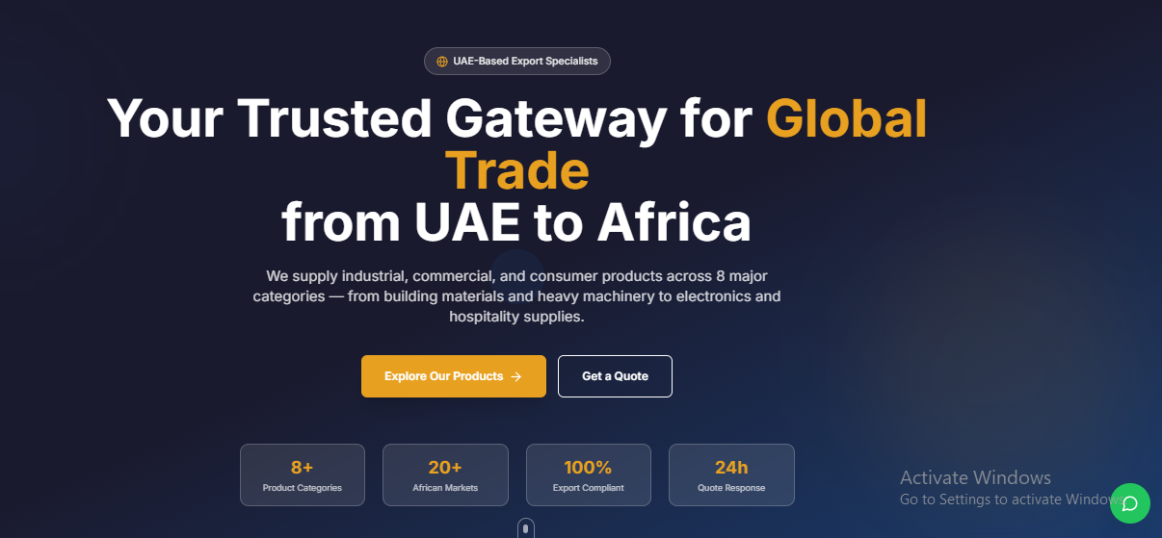

HERO 2

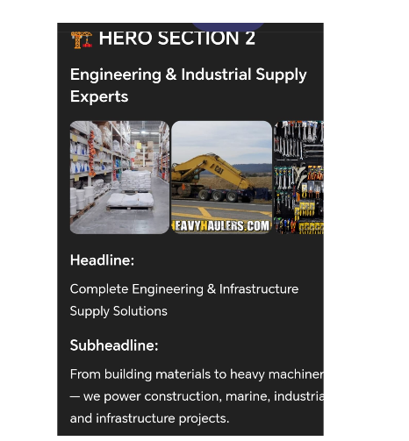
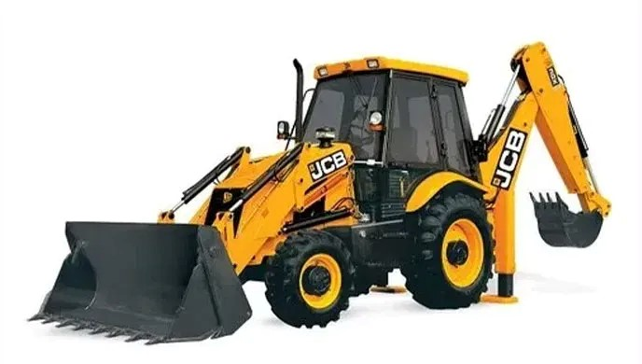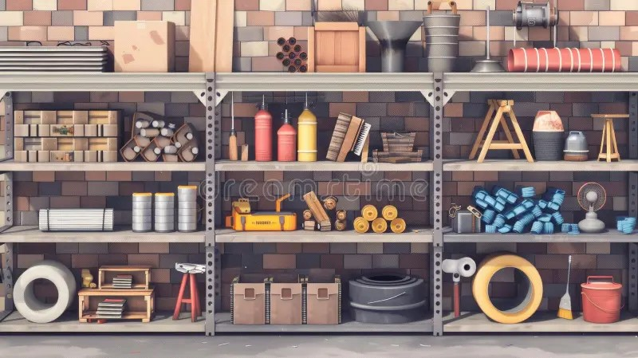
COMBINE THIS TWO IMAGES( Or similar two attractive one ) AND USE FOR HERO 2.
SO HERE TO CONTENT IS THE SAME AS ABOVE AND IMAGE TO BE COMOBINATION OF ABOVE TWO IMAGES
HERO 3
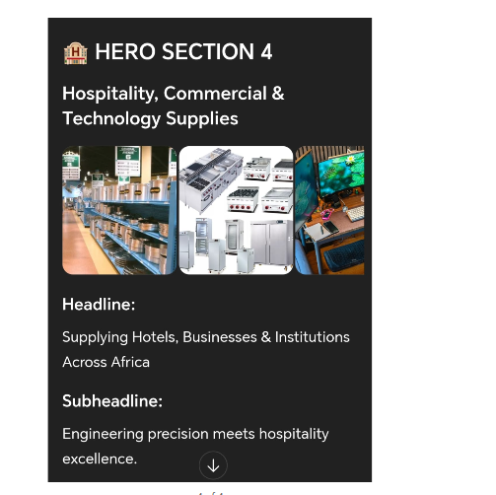 HERO 4
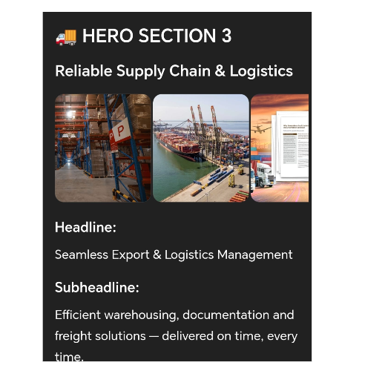

HERO 5

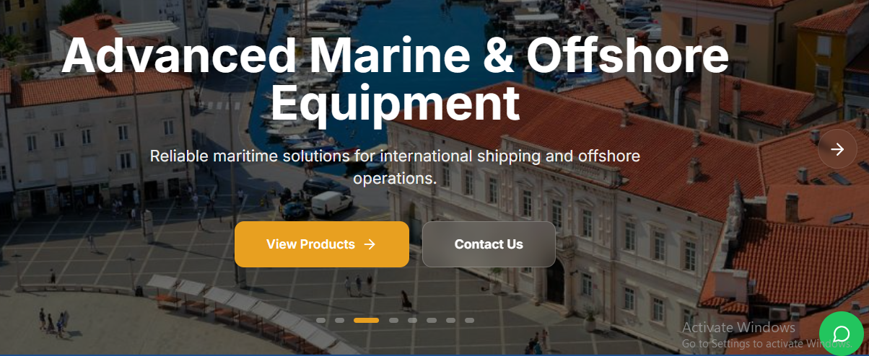
hero 5- use same content. Replace the existing Image- with similar image of yatch repair /manufacturing ( if this is high high resolution suitable for website)
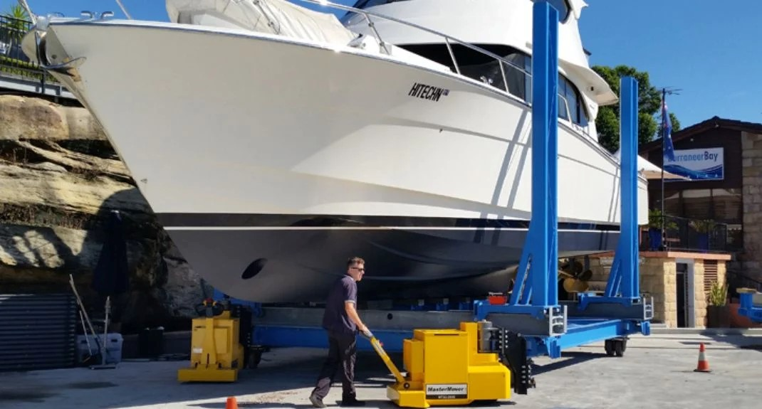

HERO 6

